**Introduction:**

In the mining process of underground metal mines, the misjudgement of rock types by on-site technicians will have a serious negative impact on the stability evaluation of rock mass and the formulation of support schemes, which will result in the loss of economic benefits and potential safety hazards of mining enterprises. In order to realize the precise and intelligent identification of rock types, the image data of peridotite, basalt, marble, gneiss, conglomerate, limestone, granite, magnetite quartzite are amplified.

**Overview**

**:**

A tremendous interest in deep learning has emerged in recent years . The most established algorithm among various deep learning models is convolutional neural network (CNN), a class of artificial neural networks that has been a dominant method in computer vision tasks since the astonishing results were shared on the object recognition. Geological research is no exception, as CNN has achieved expert-level performances in various fields Needless to say, there has been a surge of interest in the potential of CNN among geological researchers, and several studies have already been published in areas such as mineral detection using satellite images, classification of geographical terrains , image reconstruction of ocean bed and unreachable places,etc. Familiarity and utilization of this methodology would help not only researchers who apply CNN to their tasks in geology, but also the common men and farmers to identify and understand the local geology , as deep learning may influence their practice in the near future. This article focuses on the creating a rock classifier using the concepts of CNN.

**Purpose:**

The automated interpretation of rock structure can improve the efficiency, accuracy, and consistency of the geological risk assessment and better utilization of resources. Because of the high uncertainties in the geological images as a result of different regional rock types, as well as in-situ conditions (e.g., temperature, humidity, and construction procedure), previous automated methods have limited performance in classification of rock. This project presents a framework for classifying multiple rock structures based on the geological images of tunnel face using convolutional neural networks (CNN). A prototype recognition system is implemented to classify 13 types of rock structures including ‘Basalt', 'Conglomerate', 'Dolostone', 'Gabbro', 'Gneiss', 'Granite', 'Limestone', 'Marble', 'Quartzite', 'Rhyolite', 'Sandstone', 'Shale' and 'Slate’. These are the major rock types found in Indian Subcontinent.

Meanwhile, the model trained by a large database can obtain the rock features more comprehensively, leading to higher accuracy. Compared with the original classification method, the image classification method is closer to the reality considering both the accuracy and the perspective of error divergence. The experimental results reveal that the proposed method is optimal and efficient for automated classification of rock structure using the geological images of the rocks.

**Literature Survey:**

|  |  |  |  |  |
| --- | --- | --- | --- | --- |
| **S.**  **No.** | **Title of the Paper & Year**  **Published** | **Techniques Used** | **Relevance** | **Future Scope** |
| 1) | Image classification using artificial  neural networks: An experimental study on Corel database  2011 | Artificial neural  network, back propagation. | In this paper high-level image classes are inferred from low-level image features like color and shape features with the help of artificial neural network. Back  propagation neural network algorithm is used for integrating knowledge as well. | The algorithm has a fairly low accuracy of 83.21%. We can use optimization techniques to make the model more efficient. |
| 2) | Artificial neural networks and other methods of image classification  2007 | Artificial Neural  Networks (ANN),  Support Vector  Machines (SVM),  Fuzzy measures, Genetic Algorithms (GA), Fuzzy support Vector Machines (FSVM) | Demonstrates different accuracy values for traditional classification methods. | Improve the automatic techniques, and apply CNNs for a higher accuracy result. This paper also fails to consider overfitting between different models. |
| 3) | Convolutional Neural Network (CNN) for Image Detection and Recognition  2006 | CNN | Uses CNN to demonstrate classification of a UCI lung cancer dataset. | Try to improve the algorithm through heuristic algorithms. |
| 4) | Design of Artificial Neural Network Architecture for  Handwritten Digit Recognition on FPGA  2016 | 2 layer feed-forward artificial neural network | Optimizes the regular neural network using node pruning and tree pruning | N/A |
| 5) | Computational Complexity Of Neural Networks: A Survey  2011 | ANN, CNN, ANN  with back  propagation | This paper compares the time complexity of various neural networks for image classification | N/A |

|  |  |  |  |  |
| --- | --- | --- | --- | --- |
| 6) | Pruning Convolutional Neural Networks for Image Instance Retrieval  2010 | CNN, node pruning | In this paper CNNs are optimized by pruning them. This comes at a loss of accuracy but results in the neural network to be 3% faster for large datasets over 35000 entries | Different ways of optimization can be tried which lead to lesser loss of accuracy. |
| 7) | Deep Convolutional Neural Networks for Image  classification 2014 | Deep convolutional neural network, and small text mining | It exploits the use of neural network for performing sentiment analysis which is the aim of my project based on facial expressions | Improving the accuracy of the model by providing a mask for less significant features to aid in error detection in the model. |
| 8) | Improving optimization of convolutional neural networks through parameter fine-tuning  2019 | CNN,  hyperparameter tuning | This model compares the original CNN built and tests it against an optimized version of the same network by using parameter tuning method and feature reduction | As this is a comparative study not much is to be improved. |
| 9) | Optimization of convolutional neural network parameters for image classification  2017 | CNN | Method is proposed to make an improvement on the accuracy of the CNN by two means. One is by increasing the number of layers and another is to reduce the image size of the window. | As this is a comparative study not much is to be improved. |
| 10) | Very deep  convolutional neural network  based image classification using small training sample size  2015 | CNN, Regularisation, Batch normalisation | Uses regularization and batch normalization on CNN to fit small datasets with simple and proper modifications and don't need to re-design specific small networks. | We can think of optimizing the overfitting problem by removing some of the nodes in the network to make it slightly lightweight. |

**Existing Problem:**

Rocks are a fundamental component of Earth. The automatic identification of rock type in the field would aid geological surveying, education, and automatic mapping. It is a basic part of geological surveying and research, and mineral resources exploration. The automatic identification of rock type in the field would aid geological surveying, education, and automatic mapping. Working conditions in the field generally limit identification to visual methods, including using a magnifying glass for fine-grained rocks. Visual inspection assesses properties such as colour, composition, grain size, and structure. The attributes of rocks reflect their mineral and chemical composition, formation environment, and genesis. The colour of rock reflects its chemical composition. But these analysis is time taken process to identify the rocks.Its application here has effectively identified rock types from images captured in the field. This paper proposes an accurate approach for identifying rock types in the field based on image analysis using deep convolutional neural networks.

**Proposed Solution:**

Deep learning is receiving significant research attention for pattern recognition and machine learning. Its application here has effectively identified rock types from images captured in the field. This paper proposes an accurate approach for identifying rock types in the field based on image analysis using deep convolutional neural networks. The results show that the proposed approach based on deep learning represents an improvement in intelligent rock-type identification and solves several difficulties facing the automated identification of rock types in the field.Who are experienced in the field of geological they can identify the rocks easily. But who are new to the field, it can help to identify the type of rock.

**Theoretical Analysis:**

Under the Tensorflow deep learning framework, the Faster R-CNN rock type identification model was constructed by using Python programming language. Finally, the model was trained by GPU acceleration. The iterations of the whole training process is 5,000 times.

The dataset includes 13 kinds rock with different lithologies, such as including ‘Basalt', 'Conglomerate', 'Dolostone', 'Gabbro', 'Gneiss', 'Granite', 'Limestone', 'Marble', 'Quartzite', 'Rhyolite', 'Sandstone', 'Shale' and 'Slate’.. To reduce the parameters of the model, we reduce the size of each rock image to 64∗64 pixels on the premise of ensuring accuracy

**Block Diagram**:

Convolutional Neural Networks:

The convolutional neural network (CNN) is a class of deep learning neural networks. CNNs represent a huge breakthrough in image recognition. They‟re most commonly used to analyze visual imagery and are frequently working behind the scenes in image classification. They can be found at the core of everything from Facebook‟s photo tagging to self-driving cars. They‟re working hard behind the scenes in everything from healthcare to security.

The pre-processing required in a CNN is much lower as compared to other classification algorithms. While in primitive methods filters are hand-engineered, with enough training, CNN have the ability to learn these filters/characteristics. The architecture of a CNN is analogous to that of the connectivity pattern of Neurons in the Human Brain and was inspired by the organization of the Visual Cortex. Individual neurons respond to stimuli only in a restricted region of the visual field known as the Receptive Field. A collection of such fields overlap to cover the entire visual area.

##### Architecture:

Convolution Layer:

Convolution is the first layer to extract features from an input image. Convolution preserves the relationship between pixels by learning image features using small squares of input data. It is a mathematical operation that takes two inputs such as image matrix and a filter or kernel.

Strides:

Stride is the number of pixels shifts over the input matrix. When the stride is 1 then we move the filters to 1 pixel at a time. When the stride is 2 then we move the filters to 2 pixels at a time and so on. The below figure shows convolution would work with a stride of 2.

Padding

Sometimes filter does not fit perfectly fit the input image. We have two options:

* + Pad the picture with zeros (zero-padding) so that it fits
  + Drop the part of the image where the filter did not fit. This is called valid padding which keeps only valid part of the image.

Non Linearity (ReLU)

* + ReLU stands for Rectified Linear Unit for a non-linear operation. The output is *ƒ(x) = max(0,x).*
  + Why ReLU is important :ReLU‟s purpose is to introduce non-linearity in our ConvNet. Since, the real world data would want our ConvNet to learn would be non-negative linear values.

There are other non linear functions such as tanh or sigmoid that can also be used instead of ReLU. Most of the data scientists use ReLU since performance wise ReLU is better than the other two.

Pooling Layer:

Pooling layers section would reduce the number of parameters when the images are too large. Spatial pooling is also called sub sampling or down sampling which reduces the dimensionality of each map but retains important information.

Fully Connected Layer

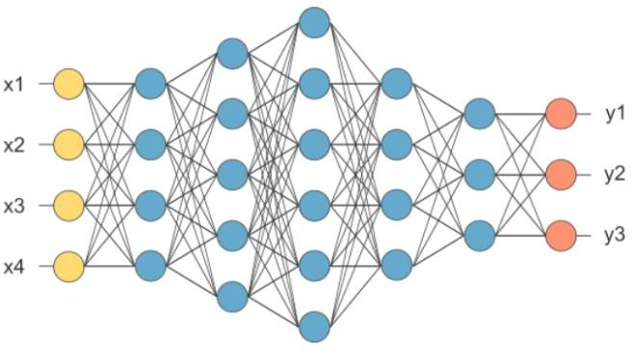

The layer we call as FC layer, we flattened our matrix into vector and feed it into a fully connected layer like a neural network.

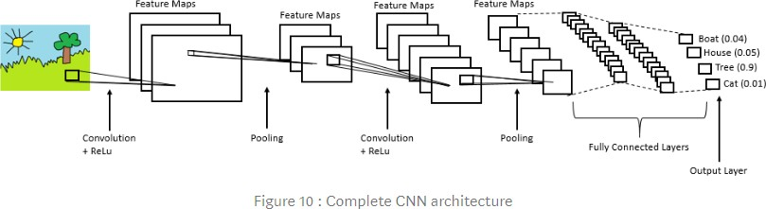

**Framework:**

In order to obtain the feature figure, the basic feature extraction network is needed to extract the rock image features. The network structure and parameters is shown. The simplified feature extraction network was composed of the convolution layer and the pooling layer. Rock image features cannot be described by simple features such as shape, and the feature law is not obvious. So, identifying rock types requires more advanced and abstract features. When performing convolution operations, it is necessary to ensure that the overall image features are not lost, and the depth of the network needs to meet the requirements of extracting abstract features. Therefore, the entire network increases network depth and improves network learning by stacking several consecutive 3×3 small convolution kernels. At the same time, in order to reduce the over-fitting and improve the generalization ability of the model, the pooling method of all pooling layers was the maximum pooling method, Finally, the length and width of the image were reduced by half after each layer of the maximum pooling operation. As a result, rock feature images will become smaller and smaller, and features will become more concentrated and abstract.

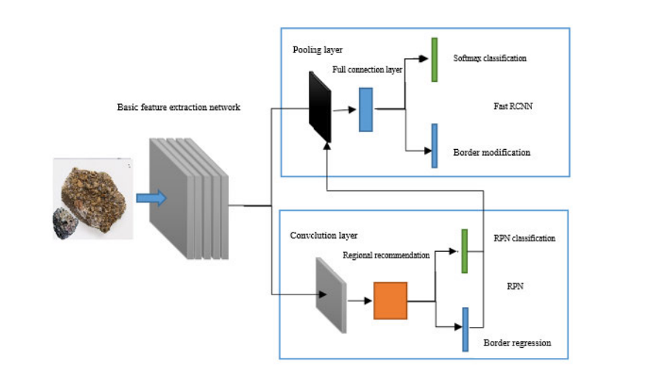

**Experimental Investigation**:

The model achieves the best results when the batch size is set to 32, which is 5% higher than the other batch size training models. When the value of batch size is large, the direction of gradient descent is more accurate, so that the model is more moderate during the training period. The smaller batch size will have more randomness, making it difficult for the model to achieve optimal results. However, when there are two or more rocks in the same photo, this method will classify them into one type of rock, which means that different types of rocks in the same image cannot be distinguished and identified correctly.

Flowchart:

**Result**:

This method takes the RGB image of the rock thin section as the input. Identifying rocks is very important for geological survey work. A new identification model is needed for automatic classification by using deep learning. This paper comprehensively analyzes models based on lightweight CNNs in terms of their recognition accuracy and time, space occupation, batch size evaluation, and comparison of heavyweight models. A rock recognition software based on lightweight CNNs model was developed. When the recognition target is a single-type rock image, the recognition probability is greater than 90%, and the rock and background can be well distinguished.

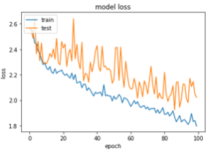

The above figure states the loss while iterating (training) with 100 epochs. It can clearly be seen losses are reducing with couple of iteration. And whith itaeration of 5000 epochs, it reduces to 0.27.

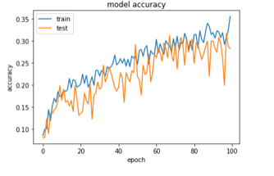

The above figure states the accuracy while iterating (training) with 100 epochs. It can clearly be seen accuracy is increasing with couple of iteration. And whith itearation of 5000 epochs, it reduces to 90 percent.

**Advantages and Disadvantages**:

Advantages:

- CNN is also computationally efficient

- The main advantage of CNN compared to its predecessors is that it automatically detects the important features without any human supervision.

Disadvantages:

-High computational cost.

- If you don't have a good GPU they are quite slow to train (for complex tasks).

-They use to need a lot of training data.

**Applications:**

1. **Decoding Facial Recognition**



Facial recognition is broken down by a convolutional neural network into the following major components -

* + Identifying every face in the picture
  + Focusing on each face despite external factors, such as light, angle, pose, etc.
  + Identifying unique features
  + Comparing all the collected data with already existing data in the database to match a face with a name.

A similar process is followed for scene labeling as well.

1. **Analyzing Documents**



Convolutional neural networks can also be used for document analysis. This is not just useful for handwriting analysis, but also has a major stake in recognizers. For a machine to be able to scan an individual's writing, and then compare that to the wide database it has, it must execute almost a million commands a minute. It is said with the use of CNNs and newer models and algorithms, the error rate has been brought down to a minimum of 0.4% at a character level, though it's complete testing is yet to be widely seen.

1. **Historic and Environmental Collections**



CNNs are also used for more complex purposes such as natural history collections. These collections act as key players in documenting major parts of history such as biodiversity, evolution, habitat loss, biological invasion, and climate change.

1. **Understanding Climate**



CNNs can be used to play a major role in the fight against climate change, especially in understanding the reasons why we see such drastic changes and how we could experiment in curbing the effect. It is said that the data in such natural history collections can also provide greater social and scientific insights, but this would require skilled human resources such as researchers who can physically visit these types of repositories. There is a need for more manpower to carry out deeper experiments in this field.

1. **Grey Areas**



Introduction of the grey area into CNNs is posed to provide a much more realistic picture of the real world. Currently, CNNs largely function exactly like a machine, seeing a true and false value for every question. However, as humans, we understand that the real world plays out in a thousand shades of grey. Allowing the machine to understand and process fuzzier logic will help it understand the grey area us humans live in and strive to work against. This will help CNNs get a more holistic view of what human sees.

1. **Advertising**



CNNs have already brought in a world of difference to advertising with the introduction of programmatic buying and data-driven personalized advertising.

1. **Other Interesting Fields**



CNNs are poised to be the future with their introduction into driverless cars, robots that can mimic human behavior, aides to human genome mapping projects, predicting earthquakes and natural disasters, and maybe even self-diagnoses of medical problems. So, you wouldn't even have to drive down to a clinic or schedule an appointment with a doctor to ensure your sneezing attack or high fever is just the simple flu and not symptoms of some rare disease. One problem that researchers are working on with CNNs is brain cancer detection. The earlier detection of brain cancer can prove to be a big step in saving more lives affected by this illness.

**Conclusion**:

The research team used the simplified convolutional neural network as the basic feature extraction network. Then, the training data can be obtained by data amplification technology, and the GPU can be used to accelerate the training of the rock type identification model. Finally, the precise identification of the images of peridotite, basalt, marble, gneiss, conglomerate, limestone, granite and magnetite quartzite was realized. When the recognition target is a single-type rock image, the recognition probability is greater than 90%, and the rock and background can be well distinguished. When the image is a multi-type rocks hybrid image, the probability of recognition of most rocks is greater than 80%. In addition, the model can also identify the types of rocks with incomplete images and complex images, which fully proves that the lithology recognition model of this study has strong robustness and generalization ability. During the whole model training and recognition process, the training data and test data are randomly selected, and there are no artificial interventions on the pixel, imaging distance and illumination intensity of the images. Moreover, the rock image features of various lithologies are automatically extracted by the convolutional network, which fully shows that the use of this model to identify the rock types is more intelligent. The research results lay the foundation for the next step to realize the on-site intelligent identification of rock lithology in underground mine.

**Future Scope**:

VGG 16 & VGG 19 may help in optimising the Convolution Neural Network result and Mobile Net may also help to use this model on hand set which ca easily be used my mine workers. Rock Identification may also include the percentage of minerals found on the rock and if any other element found on that rock. It can help us to understand the geographical history of the location. Further with help of Virtual Reality it can help to understand the soil and its rocks in depth and help in the process of petroleum. This study provides a new method for geological surveyors to automatically and quickly identify rocks of different lithologies in the field. Future research can improve the recognition ability of the model by continuously enriching the rock sample dataset or introducing other lightweight CNNs models.

**Source Code**:

**Step 1.Import Libraries**

**from** keras.models **import** Sequential

**from** keras.layers **import** Dense

**from** keras.layers **import** Convolution2D

**from** keras.layers **import** MaxPooling2D

**from** keras.layers **import** Flatten

**Step 2.Preprocessing Using Data Generator**

from keras.preprocessing.image import ImageDataGenerator

train_datagen=ImageDataGenerator(rescale=1./255,shear_range=0.8,zoom_range=0.8,horizontal_flip=True) #sher= distance increase flip,etc if not able to understand

test_datagen=ImageDataGenerator(rescale=1./255) # upper options can be used but not required

**Step 3 Load Dataset and Apply image generator class preprocessing techniques to dataset**

x_train=train_datagen.flow_from_directory(r"C:\Users\prana\Desktop\ProjectS\traindata",target_size=(64,64),batch_size=32,class_mode="categorical")

x_test=test_datagen.flow_from_directory(r"C:\Users\prana\Desktop\ProjectS\testdata",target_size=(64,64),batch_size=32,class_mode="categorical")

print(x_train.class_indices) #labels given to datasets

**Step 4 Initialize The Model**

model=Sequential()

**Step 5 Add Convolution Layer**

  model.add(Convolution2D(128,(3,3),input_shape=(64,64,3),activation="relu"))

**Step 6 Add maxpooling Layer**

model.add(MaxPooling2D(pool_size=(2,2)))

model.add(Flatten()) #Input Layer Of ANN

**Step 7 Add Hidden Layers**

model.add(Dense(units=64,init="random_uniform",activation="relu")) # Hidden Layer

model.add(Dense(units=64,init="random_uniform",activation="relu")) # Hidden Layer

model.add(Dense(units=64,init="random_uniform",activation="relu")) # Hidden Layer

model.add(Dense(units=13,init="random_uniform",activation="softmax")) # Output Layer

model.compile(loss="categorical_crossentropy",optimizer="Adam",metrics=["accuracy"])

**Step 8 Train Machine**

model.fit_generator(x_train,steps_per_epoch=709/32,epochs=5000,validation_data=x_test,validation_steps=237/32)

**Step 9 Saving the Model**

model.save("RockIdentification.h5")